. DATA FLOW DIAGRAM (DFD)

A Graphical representation is used to describe and analyze the movement of data through a system manual or automated including the processes, store of data and delays in the system. Data Flow diagrams are a central tool and the basis from which other components are developed is one of the most important modeling tools used in system design. DFD shows the flow of data through different processes in the system. Data flow Diagrams are made up of a number of symbols, which represents system components. Data flow modeling method uses four kinds of symbols, which are used to represent four system components. These are:
- External Entity

- Process

- Data Stores

- Data Flows

External Entity

An external entity is a person, department, outside organizations, or other information system that provides data to the system or receives outputs from the system. External entities are components outside of the boundaries of the information systems. They represent how the information system interacts with the outside world.
- A rectangle represents an external entity.

- They either supply data or receive data.

- They do not process data.

Process

A process receives input data and produces output with a different content or form.
Processes can be as simple as collecting input data and saving in the database, or it can be complex as producing a report containing monthly sales of all retail stores in the northwest region. Every process has a name that identifies the function it performs.
- A rounded rectangle represents a process.
  - Processes are given IDs for easy referencing.

Data store
A data store or data repository is used in a data-flow diagram to represent a situation when the system must retain data because one or more processes need to use the stored data in a later time.

- Data can be written into the data store, which is depicted by an outgoing arrow
- Data can be read from a data store, which is depicted by an incoming arrow.

Data flow
A data-flow is a path for data to move from one part of the information system to another.

A data-flow may represent a single data element such as the Customer ID or it can represent a set of data elements (or a data structure).

- Straight lines with incoming arrows are input data flow
- Straight lines with outgoing arrows are output data flows Four steps are commonly used to construct a DFD:
- Process should be named and numbered for easy reference. Each name should be representative of the process.
- The direction of flow is from top to bottom and from left to right.
- When a process is exploded into lower level details they are numbered.
- The names of data stores, sources and destinations are written in capital letters.

The basic data flow symbols are:
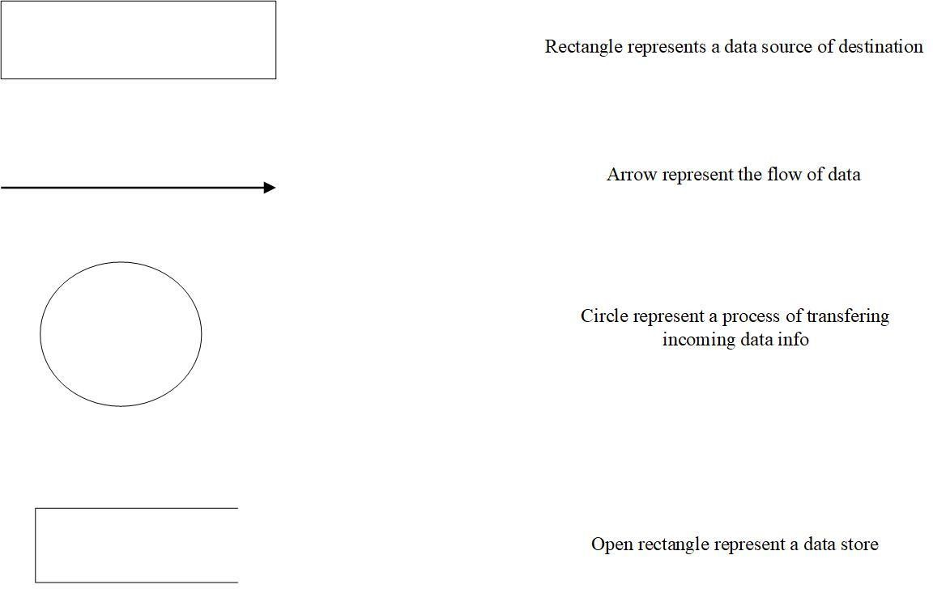

GYM MANAGEMENT SYSTEM 38
    - Data FLow Diagram
LEVEL 0 DFD:CONTEXT DIAGRAM

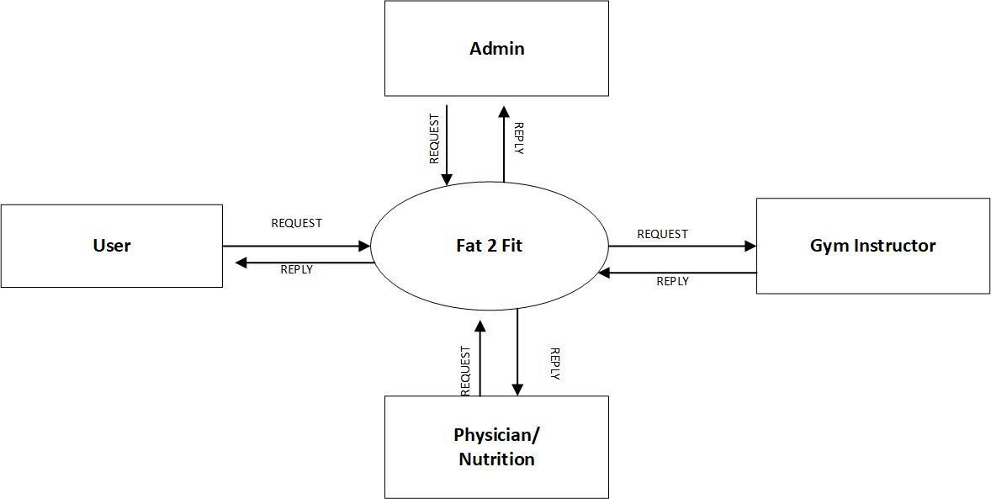

LEVEL 1 DFD: ADMIN

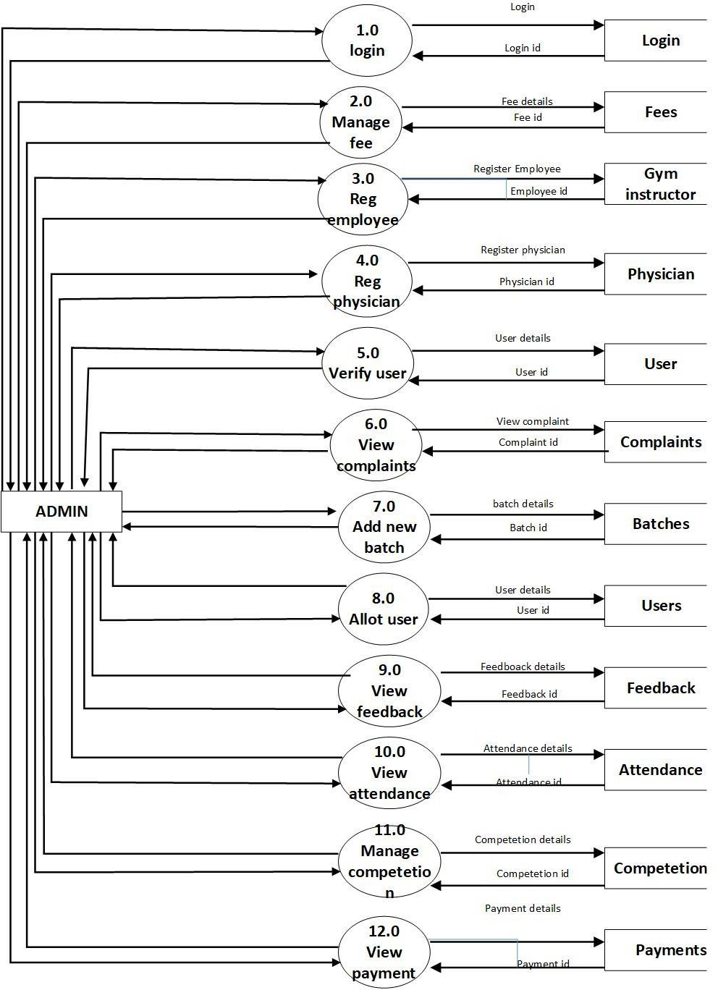

LEVEL 1 DFD: USER

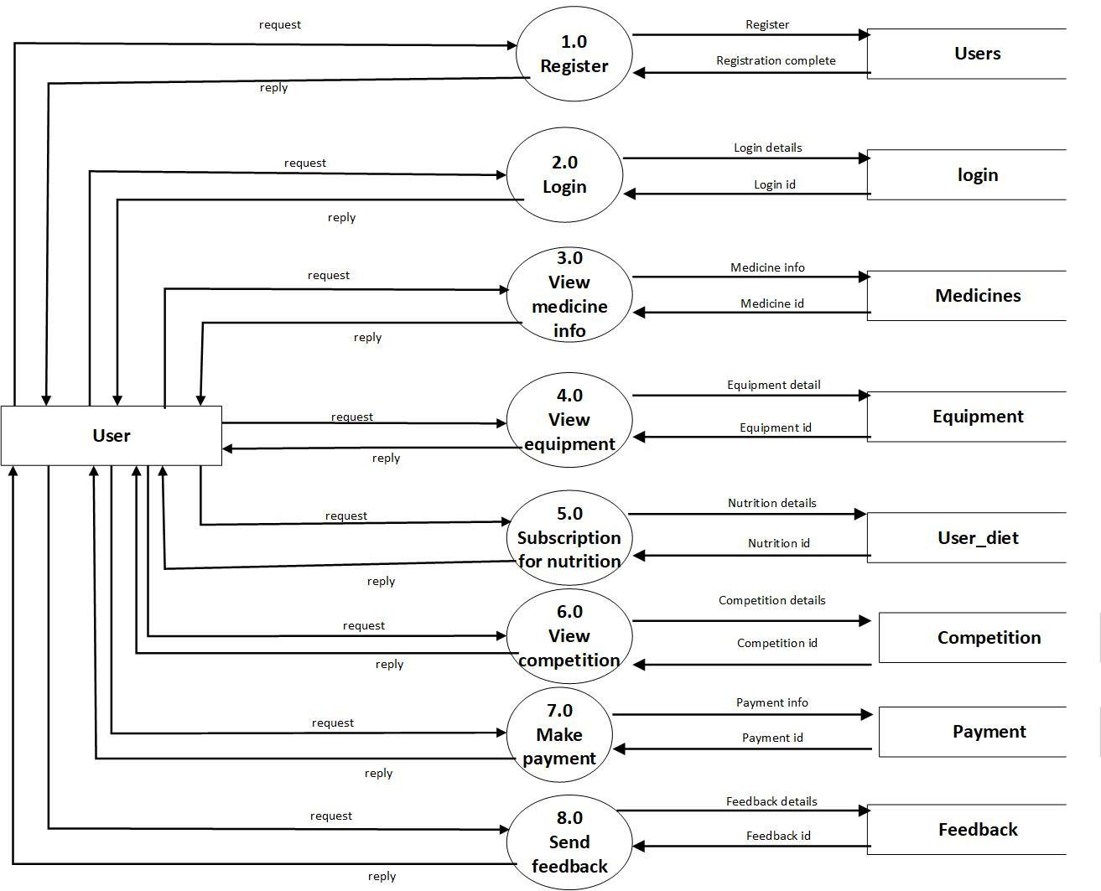

LEVEL 1 DFD: PHYSICIAN

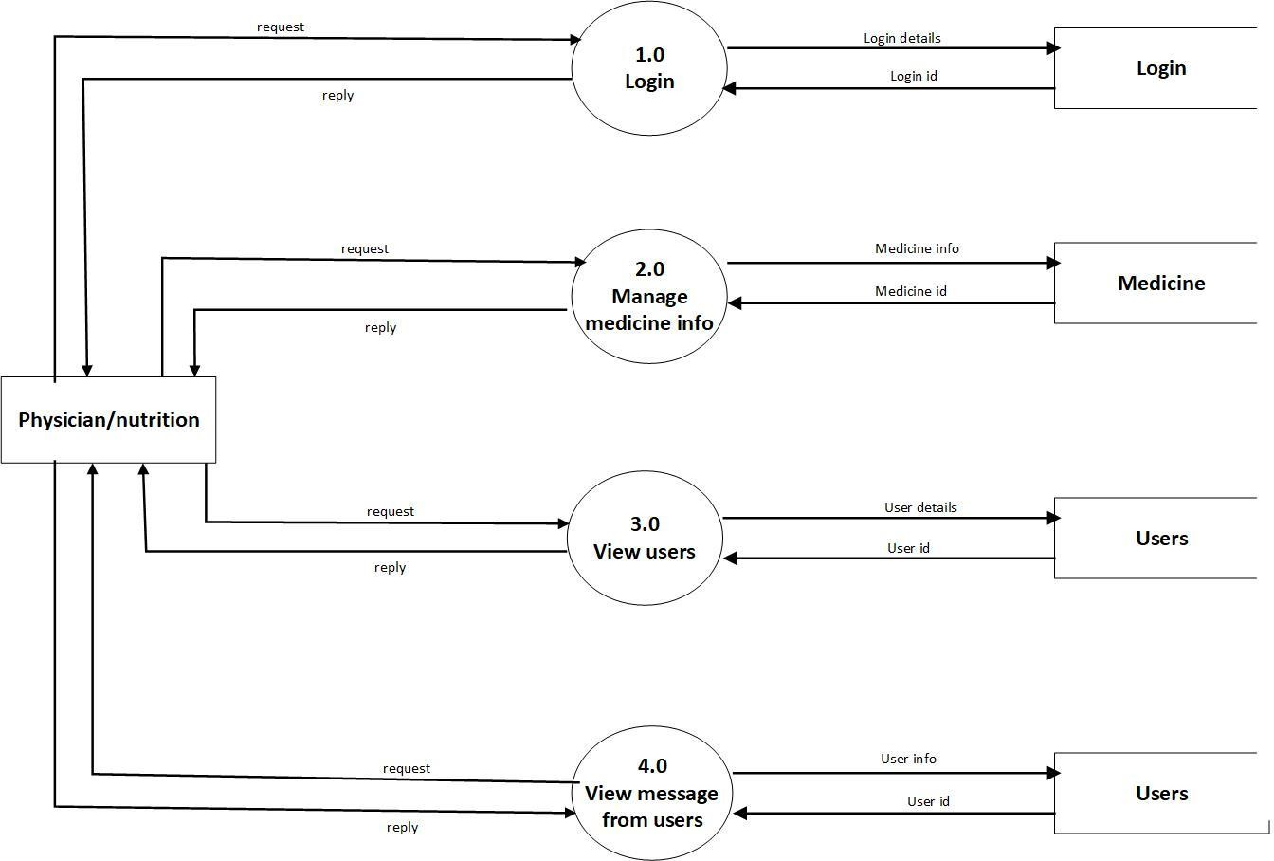

LEVEL 1 DFD: GYM INSTRUCTOR

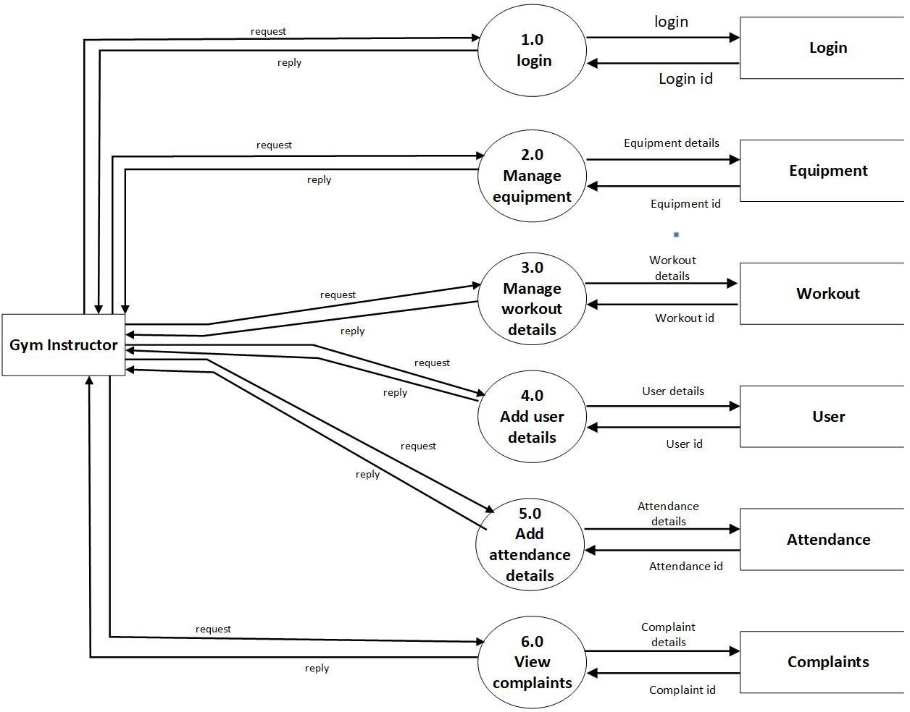

LEVEL 2 DFD: ADMIN

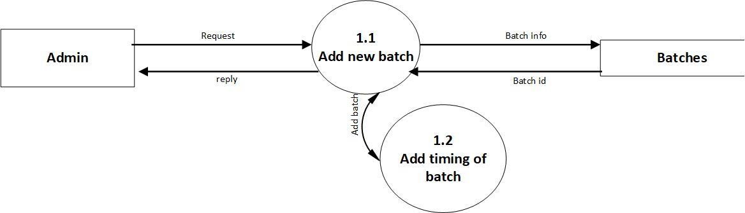

LEVEL 2 DFD: USER

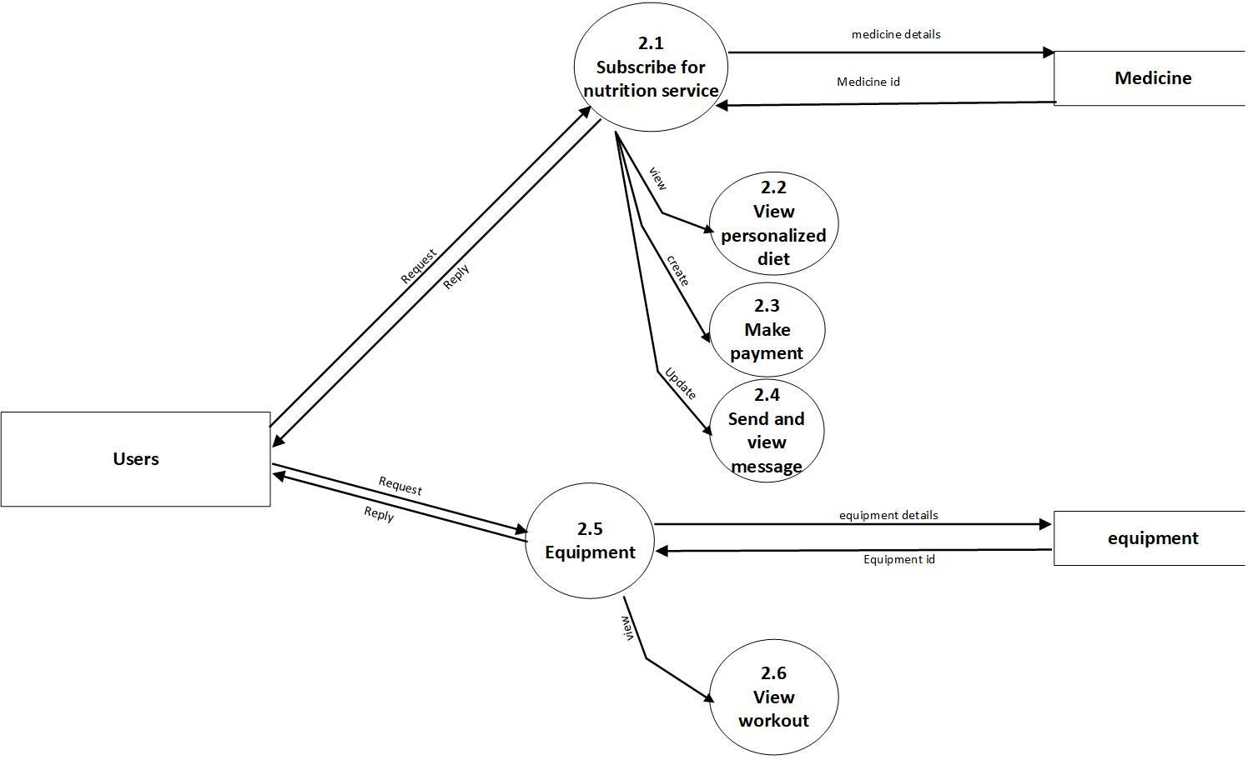

GYM MANAGEMENT SYSTEM | 44

LEVEL 2 DFD: PHYSICIAN
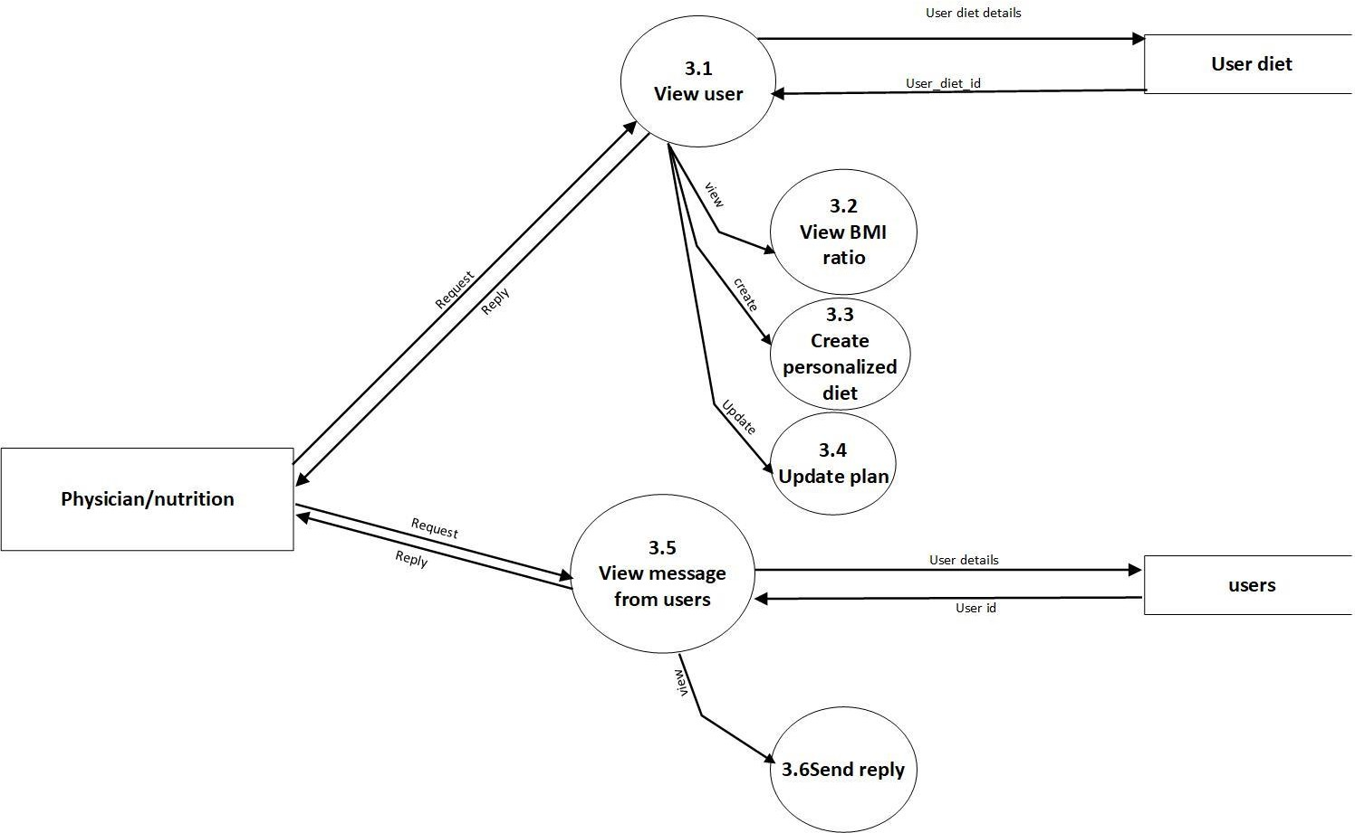

GYM MANAGEMENT SYSTEM 45

LEVEL 2 DFD: GYM INSTRUCTOR
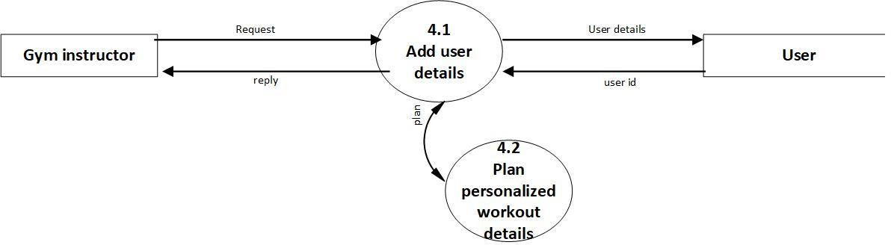

An entity-relationship model(ER model) describes inter-related things of interest in a specific domain of knowledge. An ER model is composed of entity types (which classify the things of interest) and specifies relationships that can exist between instances of those entity types. Entity- relationship modelling was developed for database design by Peter Chen and published in 1976 paper. However, the variance of the idea existed previously. Some ER modellers show super and subtype entities connected by generalization-specialization relationships, and an ER model can be used also in the specification of domain-specific ontologies. The symbols used in ER model are as follows:

ER model is based on:

        - Entities and their attributes.

        - Relationships among entities.

Entity

An entity is a database object that represents a thing in the real world. Entities are expressed as nouns.
An entity set is a collection of similar types of entities. An entity set may contain entities with attributes sharing similar values.

An attribute is a characteristic of an entity. Every entity has at least one attribute: its primary key. Attributes are expressed as nouns qualified by adjectives that clarify their role.

An attribute plays one of three possible roles in any table:

          - Primary key attributes are said to be attributes because they uniquely identify an instance of an entity.
          - A foreign key attribute can be an identifier attribute if it is part of a composite primary key; otherwise, foreign key attributes are descriptor attributes
          - Non-key attributes are said to be attributes because they specify a non-unique

          - characteristic of an instance of an entity.

Relationship

A relationship is an association among two or more entities or other relationships. Relationships are expressed as verbs. Relationships among entities are described by one of three ratios:

Relationship |  | Shorthand Notation
- One-to-one |  | o | 1:1
o | One-to-many | o | 1:M
o | Many-to-many | o | M:M

ON DEMAND GIFT DELIVERY | 48

Symbol | Shape Name | Symbol Description
Entities
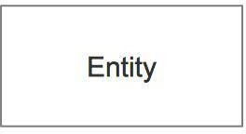 | Entity | An entity is represented by a rectangle
 |  | which contains the entity’s name.
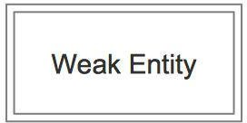 | Weak Entity | An entity that cannot be uniquely identified
 |  | by its attributes alone. The existence of a
 |  | weak entity is dependent upon another
 |  | entity called the owner entity. The weak
 |  | entity’s identifier is a combination of the
 |  | identifier of the owner entity and the partial
 |  | key of the weak entity.
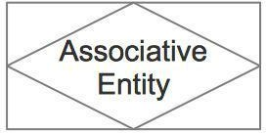 |  | An entity used in a many-to-many
 | Associative | relationship (represents an extra table). All
 | Entity | relationships for the associative entity
 |  | should be many
Attributes
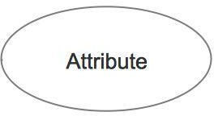 | Attribute | In the Chen notation, each attribute is
 |  | represented by an oval containing
 |  | attribute’s name

GYM MANAGEMENT SYSTEM | 49

 | 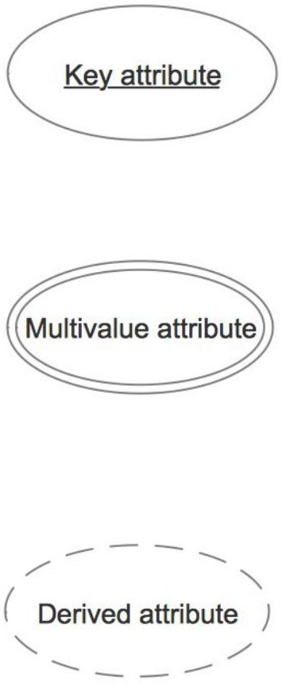  Key attribute | An | attribute that | uniquely |  | identifies a
 |  | particular entity. |  | The | name | of | a | key
 |  | attribute is underscored.
 |  | An attribute that can have many values
 | Multivalued | (there are many distinct values entered for it
 | attribute | in the same column of |  |  |  | the | table).
 |  | Multivalued attribute is depicted by a dual
 |  | oval.
 |  | An attribute whose value is calculated
 |  | (derived) from other attributes. The derived
 | Derived | attribute may or may not be physically
 | attribute | stored in the database. In the Chen notation,
 |  | this attribute is represented by a dashed
 |  | oval.
Relationships
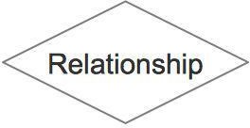 |  | A | relationship | where | an | entity |  | is
 | Strong | existence-independent of other entities, and
 | relationship | PK of Child doesn’t contain PK component
 |  | of Parent Entity. A strong relationship is
 |  | represented by a single rhombus

GYM MANAGEMENT SYSTEM | 50

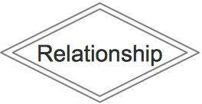 |  | A relationship where Child entity is
 | Weak | existence-dependent on parent, and PK of
 | (identifying) | Child Entity contains PK component of
 | relationship | Parent Entity. This relationship is
 |  | represented by a double rhombus.

ER DIAGRAM

